Images of our 2017 Christmas Celebration in Keene – 12/17/2017

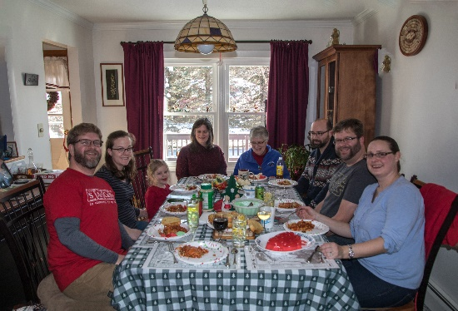Christmas is the world-wide celebration of the birth of Jesus Christ. We are fortunate that our four families can get together during this season.

Our family members gathered once again at our home in Keene, NH during the weekend of December 16-17. The timing does work out nicely and it is an enjoyable time for all.  
  
And for the photos, click on [2017 Christmas](https://photos.app.goo.gl/N2T12Vto2DqHkyCE3). Feel free to “zoom”.